**TRIBHUVAN UNIVERSITY**

**INSTITUTE OF ENGINEERING**

**LALITPUR ENGINEERING COLLEGE**

**Kholcha Pokhari, Chakupat, Lalitpur**

**MID-TERM REPORT OF MINOR PROJECT ON**

**PARICHAYA: An Identity Storage and Sharing App**

**SUBMITTED BY:**

**AARYAN SHARMA (LEC075BCT008)**

**ASIM NEPAL (LEC075BCT003)**

**KUSHAL KOIRALA (LEC075BCT020)**

**NISCHAL SHAKYA (LEC075BCT010)**

**SUBMITTED TO:**

**Department of Computer Engineering**

**LALITPUR, NEPAL**  
**2022**

Report On

**PARICHAYA: An Identity Storage and Sharing App**

Submitted as a partial fulfillment of requirement of the curriculum of Bachelor of Computer Engineering under TU

Submitted By:

**AARYAN SHARMA**

**ASIM NEPAL**

**KUSHAL KOIRALA**

**NISCHAL SHAKYA**

Under Supervision Of

**Er. Praches Acharya**

Date:

**24th February, 2022**

ACKNOWLEDGEMENT

First and foremost, we would like to thank our supervisor, Er. Binod Sapkota, who guided us in doing this project. He provided us with invaluable advice and helped us in difficult stages. His motivations helped tremendously to the successful completion of the project.

We are really grateful to our project coordinator, Er. Bisikha Subedi, for advising us and introducing the project to us in an easy to understand way which has helped us to complete our project easily and effectively on time.

We would like to express our special thanks of gratitude to IOE as well as our principal, Mr. Lallan Tiwari, who gave us the golden opportunity to do this wonderful project on the topic, DIGITAL MARKET: An Ecommerce Website, which also helped us in doing a lot of research and we came to know about so many new things. We are really thankful to them.

Besides, we would like to thank all the teachers who helped us by giving us advice and providing the equipment which we needed.

We are overwhelmed in all humbleness and gratefulness to acknowledge our depth to all those who have helped us to put these ideas, well above the level of simplicity and into something concrete.

Also we would like to thank our family and friends for their support. Without their support we wouldn’t have succeeded in completing this project.

Last but not the least, we would like to thank everyone who helped and motivate us to work on this project.

ABSTRACT

In this digital era, the act of distributing or providing access to digital media, such as computer programs, multimedia (audio, images, and video) or documents is crucial for a convenient human lifestyle. The proposed project titled, ‘PARICHAYA: An Identity Storage and Sharing App’ is a digital document/file sharing and storage application which sought to erase the concept of physical document/file sharing and also helps to encourage safety during the ongoing pandemic (covid-19). The user can register to the application by using G-mail verification method and then upload any sensitive documents or notes, such as passwords, citizenship card, driver’s license, or pins for safekeeping. Through the concept of selective data sharing, this app is able to share images or texts containing sensitive information of the user, not as a whole, but selectively as per requested by another user or the user themselves, by creating a unique QR code or link to the specified destination. The secondary user, who requested the data should be able to scan the QR code or use the link to view the required documents which is available only for the time limit as specified by the primary user (sender).

Users can benefit from this app by not having to be physically present at the specific institute for menial works such as creating a new account in a bank or admission in universities and such. Moreover, the users are not obliged to carry a copy of physical document everywhere as the whole document will be stored in the app itself.

*Keywords: Document storing, Document sharing*

TABLE OF CONTENTS

ACKNOWLEDGEMENT I

ABSTRACT II

TABLE OF CONTENTS III

LIST OF FIGURES V

LIST OF ABBREVIATIONS VI

CHAPTER 1 INTRODUCTION 1

1.1 Background 1

1.2 Problem Statement 2

1.3 Scope 3

1.4 Objective 4

CHAPTER 2 LITERATURE REVIEW 5

2.1 Existing 5

CHAPTER 3 FEASIBILITY STUDY 7

3.1 Economically Feasibility 7

3.2 Operational Feasibility 7

3.3 Technical Feasibility 7

CHAPTER 4 METHODOLOGY 8

4.1 Software development lifecycle 8

4.2 System Development Tools 10

CHAPTER 5 BLOCK DIAGRAMS 11

CHAPTER 7 IMPLEMENTATION DETAILS 15

CHAPTER 8 WORK ACCOMPLISHED 16

8.1 Adding Documents 16

8.2 Editing Document 17

8.3 Sharing Document 18

8.4 Dark Mode: 19

CHAPTER 9 REMAINING TASKS 20

CHAPTER 10 GANTT CHART 21

REFERENCES 22

LIST OF FIGURES

**Figure 1: Spiral Modal** 8

**Figure 2: Block Diagram of System** 11

**Figure 3: Use Case Diagram** 12

**Figure 4: Level 0 DFD** 13

**Figure 5: Level 1 DFD** 13

**Figure 6: ER Diagram** 14

**Figure 7: Gantt chart** 21

LIST OF ABBREVIATIONS

|  |  |
| --- | --- |
| **QR** | Quick Response |
| **DFD** | Data Flow Diagram |
| **PEP** | Python Enhancement Proposal |
| **SDK** | Software Development Kit |
| **iOS** | iPhone Operating System |
| **MTV** | Model Template View |
| **API** | Application Programming Interfaces |
| **CMS** | Content Management System |
| **SQL** | Structure Query Language |
| **BSD** | Berkeley Software Distribution |
| **MVCC** | Multi-Version Concurrency Control |
| **URL** | Uniform Resource Locator |

1. INTRODUCTION
   1. Background

Personal Information is information or an opinion that identifies an individual. Our one and only identity is the documents or the personal information we possess. All the documents such as citizenship, passports, birth certificate contains very sensitive information about us. Sensitive information is the opinion about things such as an individual's racial or ethnic origin, political opinions, membership of a political association, religious or philosophical beliefs, membership of a trade union or other professional body, educational record or health information. Banks, hospitals, airports, offices, universities and even the government institutions of Nepal collect our personal information for the primary purpose of providing services to us. So, wherever we go, we have to carry the documents which contains personal information about us. Carrying such sensitive information is very inconvenient and there is also a probability of losing the information. Instead of carrying such paper documentation with us, if we could digitalize it and make it easily available through mobile apps, it would provide both convenience and safety.

In this project, a simple user-friendly app is developed through which we can easily share selective sensitive information about us to the organization such as banks, hospitals, offices, airports or other institutions. This will mitigate the inconvenience of carrying the personal documents and also ensures safety. The main objective of this project is to develop an application for storing our personal information and to add selective sharing method, in order to provide convenience, safety and to reduce repetition.

* 1. Problem Statement

The government of Nepal and multiple different institutions require our personal documents for identifications and other formal procedures. But, carrying a copy of such sensitive documents for different multiple purposes is not convenient. Also, we might not always have access to required documents. There is also certain probability of losing such personal information as well.

Furthermore, the whole world is facing the chaotic situation due to covid-19 which makes physical presence to different institutions very problematic. Document sharing is not physically possible due to multiple quarantines and lockdowns.

Thus, to tackle all said problems, instead of carrying such paper documentation with us, if we digitalize it and make it easily available through mobile apps, it will provide both convenience and safety.

* 1. Scope

This project can be used by many service providing institutions which requires our personal information to provide services to us. The institution like bank requires our citizenship for creating a bank account. Similarly, offices requires our certificates of qualification to provide us a job. Universities requires our grades to give us admission. Hence, all these sensitive information are used by different institution to provide us the services. A situation might occur where we might not always have easy access to these physical documents. But these days everyone carries their smartphones wherever they go. So storing these documents in a smartphone makes the process of sharing these documents easier which is the main idea of the project.

* 1. Objective

To provide the platform to store personal documents and credentials, which can be shared easily to different institutes, who require it in order to provide services to users.

1. LITERATURE REVIEW

In this digital era, the act of distributing or providing access to digital media, such as computer programs, multimedia (audio, images, and video) or documents is crucial for a convenient human lifestyle.In the past, many app have been launched for document storage and sharing such as Egnyte, MediaFire which has many limitations on storge and sharing.

* 1. Existing

Nagarik App:

The government has recently launched a mobile app named Nagarik in its bid to digitize the government services. Launching the app on January 15, Prime Minister, KP Sharma Oli stated that the app was developed to facilitate an easier and systematic delivery of all government services digitally. [1] In just 10 days of its launch, the app has managed to get over 100k downloads with an average of 3.2 ratings.

ProofHub:

ProofHub is a single platform that brings together everything we need within one software suite, including a centralized file management system.[2] With ProofHub, teams can share files and collaborate directly on them using one tool. In addition to that, ProofHub allows us to integrate seamlessly with popular third-party file management apps like Google Drive, Box and Dropbox.

Google Drive:

Google Drive is a well-known cloud storage services designed to enable teams to storevideos, music, photos and more in one location. Google Drive automatically syncs data with all the devices linked to one account so that we can immediately retrieve and access the data we need. Google Drive is a file storage and synchronization service developed by Google. Launched on April 24, 2012, Google Drive allows users to store files in the cloud (on Google's servers), synchronize files across devices, and share files. In addition to a web interface, Google Drive offers apps with offline capabilities for Windows and mac OS computers, and Androidand iOS smart phones and tablets. Google Drive encompasses Google Docs, Google Sheets, and Google Slides, which are a part of the Google Docs Editors office suite that permits collaborative editing of documents, spreadsheets, presentations, drawings, forms, and more. Files created and edited through the Google Docs suite are saved in Google Drive. Google Drive offers users 15 GB of free storage through Google One. Google One also offers 100 GB, 200 GB, 2 TB, offered through optional paid plans. Files uploaded can be up to can intelligently predict the files users need.[3]

Egnyte:

Egnyte is a platform for secure, fast, and reliable file sharing. The platform meets the needs of businesses and teams around the world. The platform is flexibly priced and comes packed with a variety of feature to take collaboration and file management to a different level. If we want to share a file with someone without requiring them to log in, send them a link to a specific file.[4]

MediaFire:

MediaFire is another robust file sharing app that allows us to centralize all our files and documents. Its powerful set of features makes file management both easy and effective for us. MediaFire lets us store, accesses, share and collaborate on files with our colleagues. To ensure the safety of shared files containing confidential information, we can use one-time links that restrict recipients to share our file link with anyone else. We can upload multiple file at the same time, it has unlimited bandwidth and downloads. We can directly upload files from website using MediaFire.[5]

1. FEASIBILITY STUDY
   1. Economically Feasibility

Since the proposed system is an app which is supported on Android and iOS, so we used flutter which is a cross platform system development tool which is freely available. All the software technologies and tools which are required for development of our app are freely available in web. We use PostgreSQL as our database which is default database for macOS and is freely available on web for windows. So it’s clear that our project is economically feasible.

* 1. Operational Feasibility

Operational feasibility is based on issues such as manager support, required training, workforce reduction, and adverse effects to users and customers. Since the proposed system is interactive, the user doesn’t need any depth knowledge about the app to run. Its UI is user friendly. We use latest technology and tools for developing this app. So it will be easier to update this app in future. This app doesn’t require much technical support to maintain it. So it is feasible in operation.

* 1. Technical Feasibility

There are variety of technologies available for web development. For frontend development, we have Codename One, React Native, Ruby Motion, Kivy, Flutter as cross platform frameworks. For backend development, we have Django, node.js, php. We have used Flutter as cross platform for frontend and and Django for backend development which are open-source. So it is technically feasible.

1. METHODOLOGY
   1. Software development lifecycle

For the study of research methods, or, more formally, ‘a contextual framework' for research of this project, spiral model was chosen among all others as it enables gradual releases and refinement of a product through each phase of the spiral as well as the ability to build prototypes at each phase. **Spiral model**is one of the most important Software Development Life Cycle models, which provides support for**Risk Handling.** It has four phases: Planning, Design, Construct and Evaluation. A software project repeatedly passes through these phases in iterations (called Spirals in this model) as shown in the figure below. The Radius of the spiral at any point represents the expenses(cost) of the project so far, and the angular dimension represents the progress made so far in the current phase. In each phase of the Spiral Model, the features of the product dated and analyzed, and the risks at that point in time are identified and are resolved through prototyping.

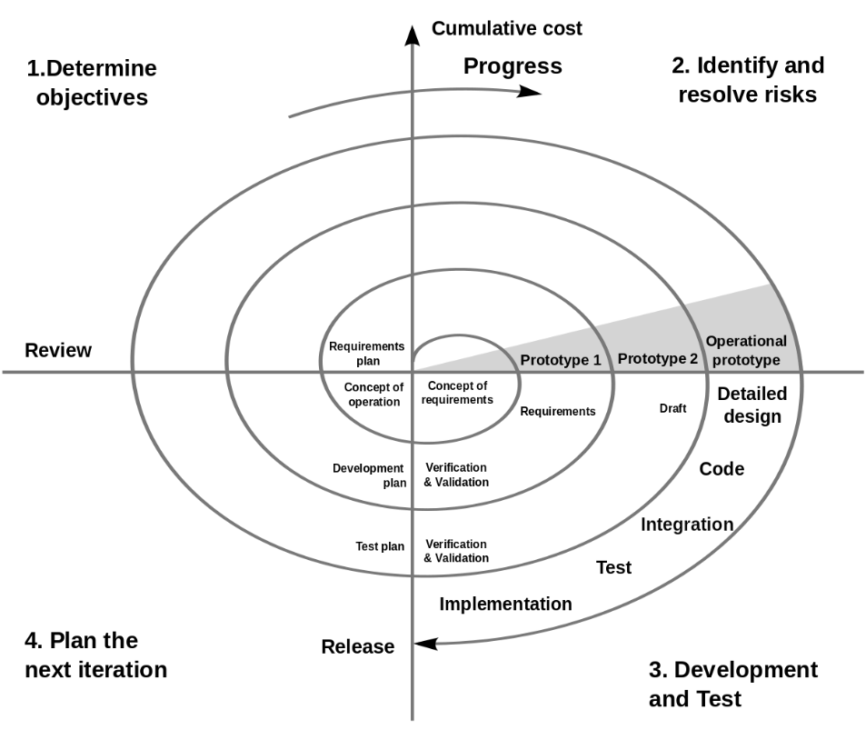

**Figure 1: Spiral Modal**

* Planning Phase:

Requirements are gathered from the customers and the objectives are identified, elaborated, and analyzed at the start of every phase. Then alternative solutions possible for the phase are proposed in this quadrant.

* Risk Analysis Phase:

During the second quadrant, all the possible solutions are evaluated to select the best possible solution. Then the risks associated with that solution are identified and the risks are resolved using the best possible strategy. At the end of this quadrant, the Prototype is built for the best possible solution.

* Development and Testing Phase:

During the third quadrant, the identified features are developed and verified through testing. At the end of the third quadrant, the next version of the software is available.

* Evaluation and Planning of next Phase:

In the fourth quadrant, the Customers evaluate the so far developed version of the software. In the end, if the Customers are satisfied with the software, then, it is released, else, planning for the next phase is started.

* 1. System Development Tools

Python:

Python is a high-level general purpose programming language which is easy to learn but has a lot of impacts in the software engineering field. It has efficient high-level data structures and object-oriented programming, which helps to emphasize code readability for small and large-scale projects. Python strives for a simpler, less-cluttered syntax and grammar while giving developers a choice in their coding methodology. It was designed to be highly extensible (with modules) which has made it particularly popular as a means of adding programmable interfaces to existing applications. The language's core philosophy is summarized in the document “The Zen of Python PEP 20”.[6]

Flutter:

Flutter apps are written in the Dart language and make use of many of the language's more advanced features. While writing and debugging an app, Flutter uses Just in Time compilation, allowing for "hot reload", with which modifications to source files can be injected into a running application. Flutter's engine, written primarily in C++, provides low-level rendering support using Google's Skia graphics library. Additionally, it interfaces with platform-specific SDKs such as those provided by Android and iOS.It implements Flutter's core libraries, including animation and graphics, file and network I/O, accessibility support, plugin architecture, and a Dart runtime and compile toolchain.[7]

Django:

Django is a high-level Python-based free and open-source web framework that follows the model–template–views (MTV) architectural pattern and encourages rapid development and clean, pragmatic design. Django was designed to help developers take applications from concept to completion as quickly as possible while being reassuringly secure and exceedingly scalable. Django's configuration system allows third party code to be plugged into a regular project, provided that it follows the reusable app conventions.[8]

1. BLOCK DIAGRAMS

System Overview:

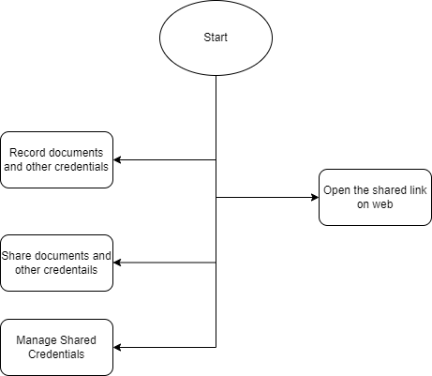

**Figure 2: Block Diagram of System**

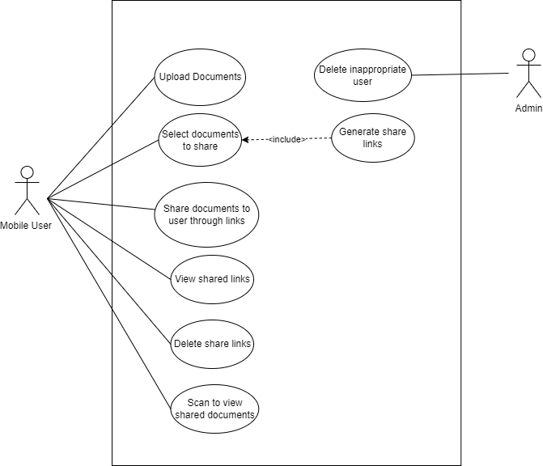Use Case Diagram:

**Figure 3: Use Case Diagram**

Data Flow Diagrams:

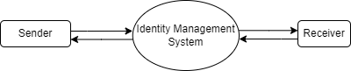

**Figure 4: Level 0 DFD**

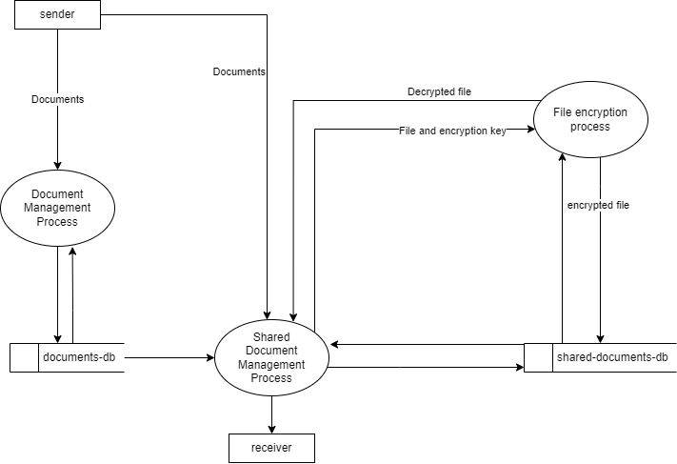

**Figure 5: Level 1 DFD**

**ER Diagram:**

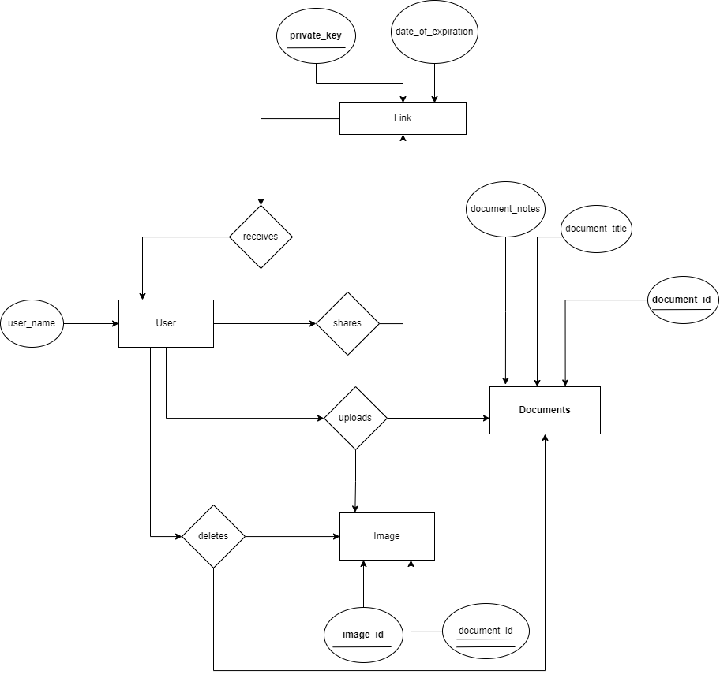

**Figure 6: ER Diagram**

1. IMPLEMENTATION DETAILS

We have used Flutter for frontend and Django for backend. Different widgets in flutter are used to develop basic UI like navigation bar, app bar, etc. in our app. The widgets like SingleChildScrollView, Container, Row, Column, Center, Listview etc are used to fulfill the purposes of making the app scrollable, making lists in our app and so on. Also flutter’s database “sqflite” is used as local mobile database and PostgreSql is used as server database for our app. In server database, data are stored in server once user shares their data through link. The data shared through link has time limitation, so the data are automatically deleted from the server database once the link expires. Also our app has local database to store the data locally**.** The backend is programmed to handle CRUD operations through APIs. Whenever user shares the data, the process of uploading the data in the server is handled by the backend. And whenever user accesses the link the process of accessing the data through the link is done by flutter webapp.

1. WORK ACCOMPLISHED
   1. 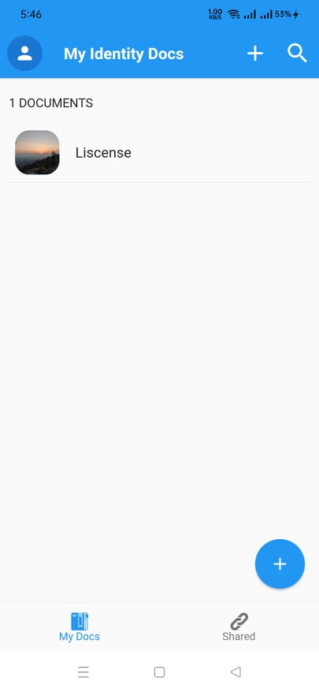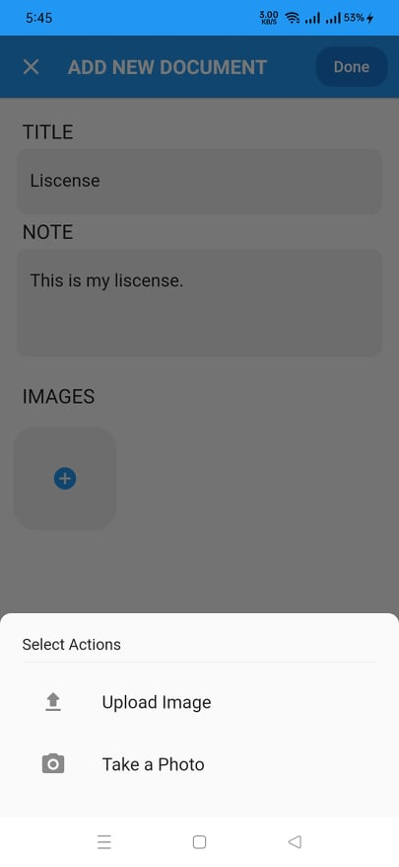Adding Documents

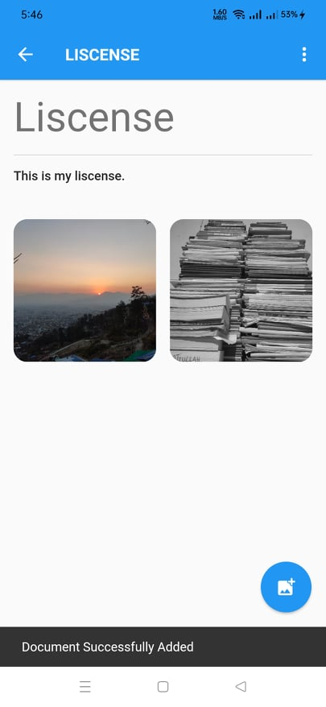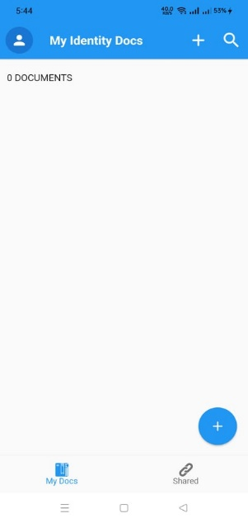

This is the homepage of our app. Here, we can upload our multiple documents related to our identity just by tapping on “My Docs”. We can upload the “Title”, “Note” and “Images” from our “ADD NEW DOCUMENT PAGE”. The images can be multiple and we can upload images both from the local gallery and by taking photo. The “shared” button gives us the information about the documents we shared and also we can share the documents from there.

* 1. 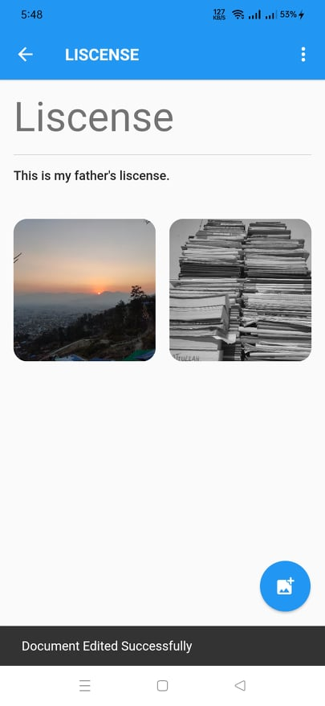Editing Document

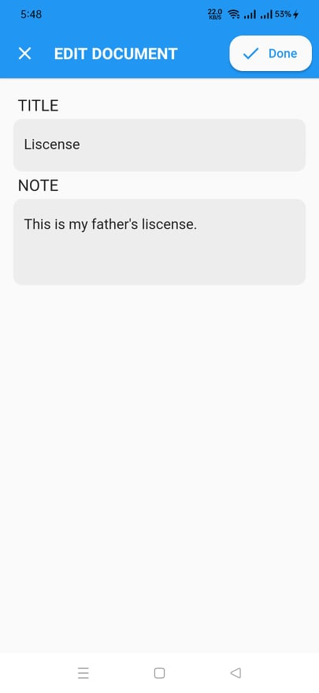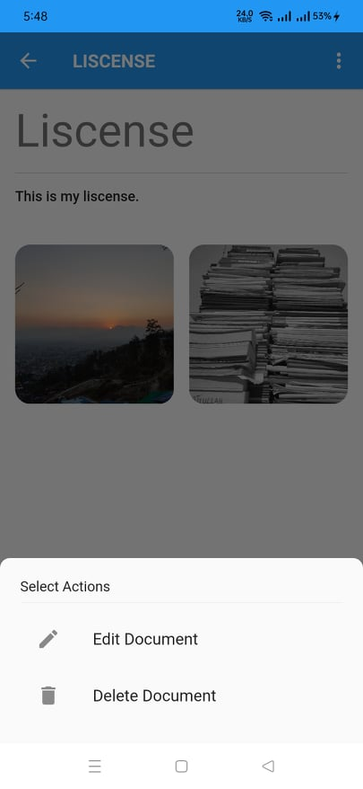

Title, note and images all can be edited from our “Edit Document” page. The example of updated note is shown in the above picture.

* 1. 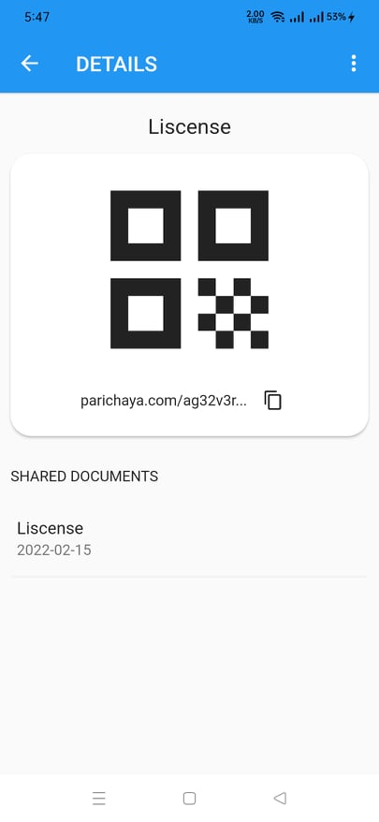Sharing Document

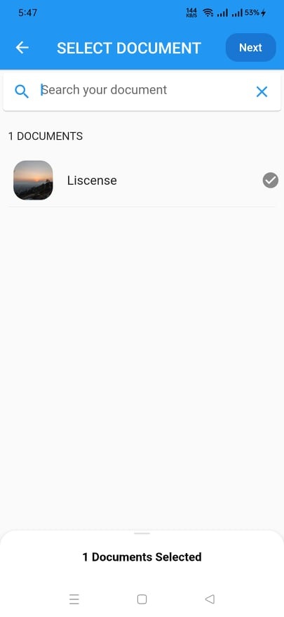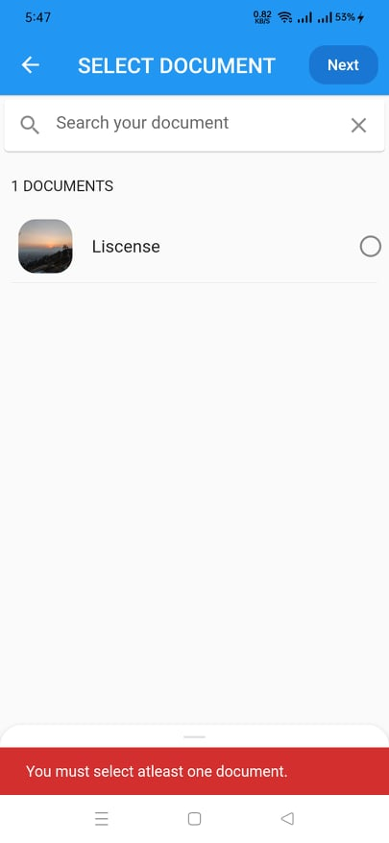

Here, if we don’t select any document and click on next button we will get error message. We can proceed to other screen thorough “Next” button only if we select some document. The link of the document we want to share is generated. The link can be copied and can be shared.

* 1. 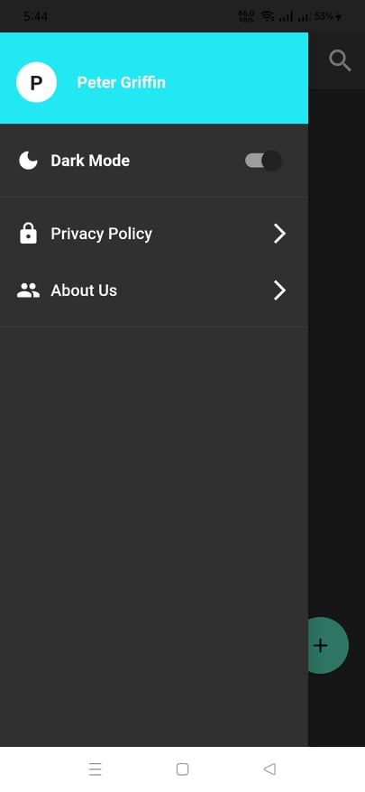Dark Mode:

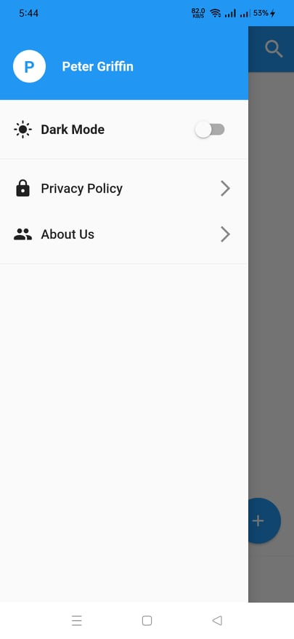

There is dark mode in our app, a simple toggle that lets us change the theme of our app. It is an optional theme in our app which can reduce power usage by a significant amount and improves the visibility for users during night light.

1. REMAINING TASKS

The main purpose of our app is storing and sharing document. We have completed the task of storing data successfully on our app and the system of sharing those documents is yet to be developed. Also the link generated to share those data is yet to be encrypted. The process of encryption is done by providing the custom key to the server which will encrypt the uploaded file based on this key. Also in our app user can select their favorite documents which is yet to be developed.

1. GANTT CHART

**Figure 7: Gantt chart**

REFERENCES

|  |  |
| --- | --- |
| [1] | OnlineKhabar, "Nagarik App," 25 January 2021. [Online]. Available: https://english.onlinekhabar.com/nagarik-app-heres-everything-you-need-to-know-to-use-nepal-govts-digitising-tool.html. |
| [2] | ProofHub. [Online]. Available: https://www.proofhub.com/. |
| [3] | T. Douglas-Bate, 06 September 2021. [Online]. Available: https://www.tomsguide.com/features/best-file-sharing-apps-to-share-files-securely. |
| [4] | Egnyte, 2021. [Online]. Available: https://www.egnyte.com/. |
| [5] | Mediafire, 2021. [Online]. Available: https://www.mediafire.com/. |
| [6] | python.org. [Online]. Available: https://www.python.org/. |
| [7] | docs.flutter.dev. [Online]. Available: https://docs.flutter.dev/. |
| [8] | docs.djangoproject.com. [Online]. Available: https://docs.djangoproject.com/en/4.0/. |
| [9] | postgresql.org. [Online]. Available: https://www.postgresql.org/. |